1. **CCNA Security**

**Lab - Exploring Encryption Methods**

1. **Objectives**

**Part 1A: Decipher a Pre-encrypted Message Using the Vigenère Cipher**

* Use an encrypted message, a cipher key, and the Vigenère cipher square to decipher the message.

**Part 2: Create a Vigenère Cipher Encrypted Message and Decrypt It**

* Work with a lab partner and agree on a secret password.
* Create a secret message using the Vigenère cipher and the key.
* Exchange messages and decipher them using the pre-shared key.
* Use an interactive Vigenère decoding tool to verify decryption.

1. **Background**

The Cisco IOS password encryption service uses a Cisco-proprietary algorithm that is based on the Vigenère cipher. Vigenère is an example of a common type of cipher mechanism called polyalphabetic substitution. Although not a strong encryption technique, Vigenère serves to illustrate a commonly used encryption and decryption process.

1. **Required Resources**

End user device with Internet access

1. **Decipher a Pre-encrypted Message Using the Vigenère Cipher**

In Part 1A, you analyze an encrypted message and decrypt it using a cipher key and the Vigenère cipher square.

* + 1. **Review the encrypted message.**

The following message has been encrypted using the Vigenère cipher:

**VECIHXEJZXMA**

* + 1. **Review the cipher keyword.**

The cipher keyword **TCPIP** was used to encrypt the message. The same keyword will be used to decrypt or decipher the message.

* + 1. **Review the structure of the Vigenère square.**

A standard Vigenère square or table is used with the keyword to decipher the message.

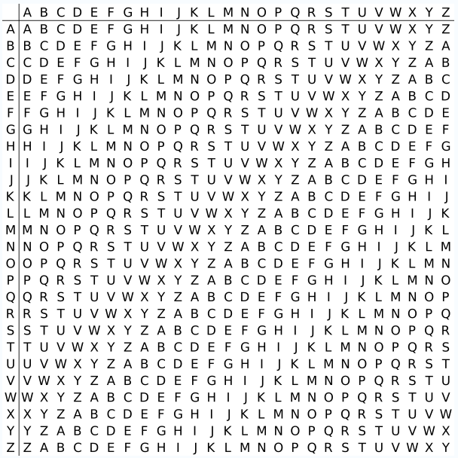

* + 1. **Decrypt the message using the keyword and Vigenère square.**
       1. Use the table below to help you decrypt the message. Start by entering the letters of the encrypted message in the second row of cells, from left to right.
       2. Enter the keyword TCPIP in the top row, repeating the letters until there is a keyword letter for each letter of the encrypted message, even if the keyword letters at the end do not represent the complete keyword.
       3. Refer to the Vigenère square or table shown in Step 3 and find the horizontal row that starts with the first letter of the keyword (the letter T). Scan across that row and locate the first letter of the encrypted message in the row (the letter V). The letter at the top of the column where the encrypted message letter appears is the first letter of the decrypted message (the letter C).
       4. Continue this process until you have decrypted the entire message and enter it in the following table.

|  |  |  |  |  |  |  |  |  |  |  |  |  |
| --- | --- | --- | --- | --- | --- | --- | --- | --- | --- | --- | --- | --- |
| **Cipher Keyword** | T | C | P | I | P | T | C | P | I | P | T | C |
| **Encrypted Message** | V | E | C | I | H | X | E | J | Z | X | M | A |
| **Decrypted Message** | C | C | N | A | S | E | C | U | R | I | T | Y |

**Part 1B**

**Encrypted Message: H sktd jdmbvhysl**

**Cipher Keyword: btec**

**Decrypted Message:…………………………………………………………**

**Create a Vigenère Cipher Encrypted Message and Decrypt It**

In **Part 2**, work with a lab partner and agree on a secret password, referred to as the pre-shared key. Each lab partner creates a secret message using the Vigenère cipher and the key. Partners exchange messages and decipher them using their pre-shared key.

* + 1. **Determine the cipher keyword.**

With your partner, establish a cipher keyword and enter it here.

_______________________________________________________________________________________

_______________________________________________________________________________________

* + 1. **Create a plain text message and encrypt it (both partners).**
       1. Create a plain text (decrypted) message to be encrypted by your partner.

____________________________________________________________________________________

____________________________________________________________________________________

* + - 1. You can use the following table to help you encrypt the message. You can enter the unencrypted message and cipher keyword here, but do not let your partner see it.
      2. In the Vigenère table, locate the row that starts with the first letter of the cipher keyword. Next locate the first letter to be encrypted at the top of the column in the table. The point (cell) at which the table row (key letter) and column (message letter) intersect is the first letter of the encrypted message. Continue this process until you have encrypted the entire message.

**Note**: This table is limited to messages of **12 characters**. You can create longer messages if desired. Message encryption and decryption is not case-sensitive.

|  |  |  |  |  |  |  |  |  |  |  |  |  |
| --- | --- | --- | --- | --- | --- | --- | --- | --- | --- | --- | --- | --- |
| **Cipher Keyword** |  |  |  |  |  |  |  |  |  |  |  |  |
| **Encrypted Message** |  |  |  |  |  |  |  |  |  |  |  |  |
| **Decrypted Message** |  |  |  |  |  |  |  |  |  |  |  |  |

* + 1. **Decrypt the message from your partner.**
       1. You can use the following table to help you decrypt your partner’s encrypted message. Enter the encrypted message from your partner and the cipher keyword.
       2. Use the same procedure described in Part 1, Step 4.

**Note**: This table is limited to messages of 12 characters. You can create longer messages if desired.

|  |  |  |  |  |  |  |  |  |  |  |  |  |
| --- | --- | --- | --- | --- | --- | --- | --- | --- | --- | --- | --- | --- |
| **Cipher Keyword** |  |  |  |  |  |  |  |  |  |  |  |  |
| **Encrypted Message** |  |  |  |  |  |  |  |  |  |  |  |  |
| **Decrypted Message** |  |  |  |  |  |  |  |  |  |  |  |  |

1. **Reflection**
   1. Could the Vigenère cipher be used to decode messages in the field without a computer?

_______________________________________________________________________________________

_______________________________________________________________________________________

_______________________________________________________________________________________

_______________________________________________________________________________________

* 1. Search the Internet for Vigenère cipher cracking tools. Is the Vigenère cipher considered a strong encryption system that is difficult to crack?

_______________________________________________________________________________________

_______________________________________________________________________________________

_______________________________________________________________________________________

_______________________________________________________________________________________